**What is ASP.NET Core?**

ASP.NET Core is an open-source, cross-platform framework for building modern, cloud-based, and internet-connected applications. It is a complete rewrite of ASP.NET, designed to be fast, flexible, and modular, with a focus on performance and maintainability. Here are some key features and aspects of ASP.NET Core:

1. **Cross-Platform**: ASP.NET Core applications can run on Windows, macOS, and Linux, enabling developers to use the operating system of their choice and deploy to a wide range of environments.
2. **Performance**: ASP.NET Core is optimized for performance, often showing significant improvements over traditional ASP.NET. It includes a lightweight, high-performance web server called Kestrel.
3. **Modular**: The framework is designed to be modular, meaning you can include only the libraries and features you need for your application, reducing the application's footprint and improving performance.
4. **Unified Framework**: ASP.NET Core unifies the development model for web UI (ASP.NET Core MVC) and web APIs, allowing for a more streamlined and consistent development experience.
5. **Dependency Injection**: Built-in support for dependency injection throughout the framework makes it easy to manage dependencies and implement patterns like Inversion of Control (IoC).
6. **Middleware**: ASP.NET Core introduces a new, flexible pipeline for handling HTTP requests using middleware components. Middleware can be added, removed, or reordered to customize how requests are processed.
7. **Configuration**: ASP.NET Core offers a new configuration system that is flexible and easy to use. It supports multiple sources, such as JSON files, environment variables, and command-line arguments.
8. **Cloud-Ready**: ASP.NET Core is designed with cloud deployment in mind, with features for integration with cloud services and easy configuration for different environments (development, staging, production).
9. **Open Source and Community-Driven**: ASP.NET Core is developed as an open-source project on GitHub, encouraging community contributions and feedback. It benefits from a large and active community of developers.
10. **Built-in Support for Modern Web Development**: ASP.NET Core includes features for building modern web applications, such as support for Razor Pages, SignalR for real-time communication, and Blazor for creating interactive web UIs using C# instead of JavaScript.

**Example Structure of an ASP.NET Core Application**

Here is a basic overview of the structure of an ASP.NET Core application:

* **Program.cs**: Contains the main entry point of the application, setting up the web host and configuration.
* **Startup.cs**: Configures the services and the middleware pipeline for the application.
* **Controllers**: Contains the controller classes for handling HTTP requests in an MVC or Web API application.
* **Views**: Contains the Razor view files for rendering UI in an MVC application.
* **wwwroot**: Contains static files like JavaScript, CSS, and images.
* **appsettings.json**: Contains configuration settings for the application.

**What are the key differences between ASP.NET Core and ASP.NET?**

ASP.NET Core and ASP.NET (also known as ASP.NET Framework or ASP.NET Classic) are both web development frameworks developed by Microsoft. However, they have several key differences due to ASP.NET Core being a complete rewrite and redesign of the original ASP.NET framework. Here are some of the key differences:

**1. Cross-Platform vs. Windows-Only**

* **ASP.NET Core**: Cross-platform. It can run on Windows, macOS, and Linux.
* **ASP.NET**: Windows-only. Designed to run on the Windows operating system.

**2. Performance**

* **ASP.NET Core**: Designed for high performance and scalability. It includes a lightweight and high-performance server (Kestrel).
* **ASP.NET**: Generally slower in performance compared to ASP.NET Core due to its older architecture and dependency on the Windows OS.

**3. Modularity**

* **ASP.NET Core**: Highly modular. Developers can include only the packages and features they need, resulting in leaner applications.
* **ASP.NET**: Less modular. It includes a lot of features and functionalities by default, which can result in heavier applications.

**4. Dependency Injection**

* **ASP.NET Core**: Built-in dependency injection is a core part of the framework.
* **ASP.NET**: Dependency injection is not built-in but can be added using third-party libraries (e.g., Unity, Autofac).

**5. Configuration**

* **ASP.NET Core**: Modern, flexible configuration system using JSON, XML, INI files, and environment variables.
* **ASP.NET**: Uses Web.config files for configuration, which is less flexible.

**6. Hosting and Deployment**

* **ASP.NET Core**: Can be self-hosted or hosted on IIS, Nginx, Apache, or Docker. Offers more flexibility in deployment options.
* **ASP.NET**: Primarily hosted on IIS.

**7. Middleware Pipeline**

* **ASP.NET Core**: Uses a middleware pipeline for handling HTTP requests, which provides more control and flexibility.
* **ASP.NET**: Uses HTTP modules and handlers, which are less flexible compared to the middleware approach.

**8. Unified Development Model**

* **ASP.NET Core**: Combines MVC and Web API into a single framework, providing a unified development model.
* **ASP.NET**: MVC and Web API are separate frameworks with different development models.

**9. Razor Pages**

* **ASP.NET Core**: Introduces Razor Pages, a page-based programming model that simplifies building web UIs.
* **ASP.NET**: Does not have Razor Pages. Uses Web Forms, MVC, and Web API separately.

**10. Static Files**

* **ASP.NET Core**: Static files are served from the wwwroot folder by default.
* **ASP.NET**: Static files can be served from any folder within the application.

**11. Project Structure**

* **ASP.NET Core**: More flexible project structure. Can use the new .csproj format, which is simpler and more readable.
* **ASP.NET**: Uses the old .csproj format, which is more complex and less flexible.

**12. Open Source and Community-Driven**

* **ASP.NET Core**: Open-source and developed on GitHub, encouraging community contributions.
* **ASP.NET**: Primarily developed by Microsoft with limited open-source involvement.

In summary, ASP.NET Core represents a significant evolution in web application development, offering modern features, improved performance, and cross-platform capabilities that make it more suitable for today’s development needs.

**What is the Program class in ASP.NET Core?**

The **Program** class in ASP.NET Core is the entry point for the application. It is responsible for setting up and starting the application. This class contains the **Main** method, which is the standard entry point for a .NET application. In the **Program** class, you configure and launch the web host, which includes setting up the server and other necessary configurations for your web application.

**Key Components of the Program Class**

1. **Main Method**: The entry point of the application.
2. **CreateHostBuilder Method**: A method that configures and returns an **IHostBuilder** which is responsible for configuring the host for the application.

Here’s a typical **Program** class in an ASP.NET Core application:

=>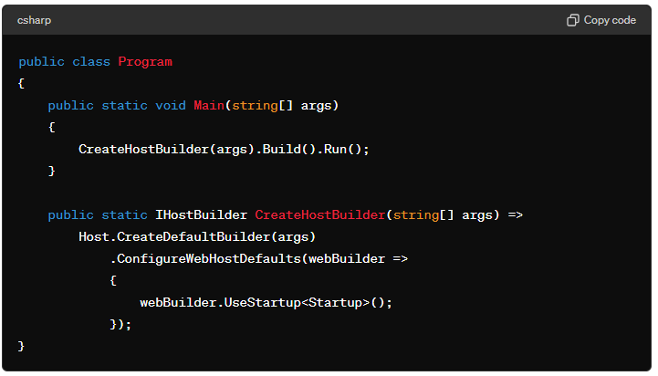 { webBuilder.UseStartup<Startup>(); }); }

**Detailed Breakdown**

1. **Main Method**:
   * This is the entry point of the application.
   * **CreateHostBuilder(args).Build().Run();**:
     + **CreateHostBuilder(args)**: Calls the method to configure the host.
     + **.Build()**: Builds the host.
     + **.Run()**: Runs the application, blocking the calling thread until the host is shut down.
2. **CreateHostBuilder Method**:
   * Returns an **IHostBuilder** that is used to configure the host for the application.
   * **Host.CreateDefaultBuilder(args)**:
     + Creates a new instance of the **HostBuilder** with pre-configured defaults.
     + Configures services, logging, configuration sources (like appsettings.json), and other middleware.
   * **.ConfigureWebHostDefaults(webBuilder => { webBuilder.UseStartup<Startup>(); })**:
     + Configures the web host to use the **Startup** class for configuring services and the app's request pipeline.

**Using Minimal Hosting Model (ASP.NET Core 6.0 and later)**

In ASP.NET Core 6.0 and later, you can use a minimal hosting model which simplifies the **Program** class:

**Key Differences in Minimal Hosting Model**

1. **WebApplication.CreateBuilder**: Combines the functionalities of **Host.CreateDefaultBuilder** and **ConfigureWebHostDefaults** into a single method call.
2. **Single Program.cs File**: Simplifies the structure by reducing the need for separate **Program.cs** and **Startup.cs** files. All configurations and middleware registrations can be done in a single file.
3. **Concise and Readable**: Provides a more concise and readable way to set up and run the application.

In conclusion, the **Program** class is fundamental in setting up and launching an ASP.NET Core application. It defines how the application is hosted, configures essential services, and integrates the **Startup** class for further configurations. The introduction of the minimal hosting model in ASP.NET Core 6.0 further streamlines this process, making it easier and quicker to get started with ASP.NET Core applications.

**What are middleware components in ASP.NET Core?**

Middleware components in ASP.NET Core are software components that are assembled into an application pipeline to handle requests and responses. Each component in the pipeline has the opportunity to process incoming requests and outgoing responses, and decide whether to pass the request on to the next component in the pipeline or to end the request processing.

**Key Features of Middleware Components**

1. **Request Delegation**: Middleware components can call the next middleware in the pipeline or terminate the request processing.
2. **Modular and Composable**: Middleware components are modular and can be composed to form the request processing pipeline.
3. **Asynchronous**: Middleware components are typically asynchronous, allowing for non-blocking I/O operations.

**Common Middleware Components**

* **Static File Middleware**: Serves static files (e.g., HTML, CSS, JavaScript).
* **Routing Middleware**: Defines and maps endpoints to request handlers.
* **Authentication Middleware**: Provides authentication services.
* **Authorization Middleware**: Provides authorization services.
* **Exception Handling Middleware**: Captures and handles exceptions.

**Example of Middleware Pipeline Configuration**

Here's a simple example demonstrating how middleware components are configured in the **Startup** class:

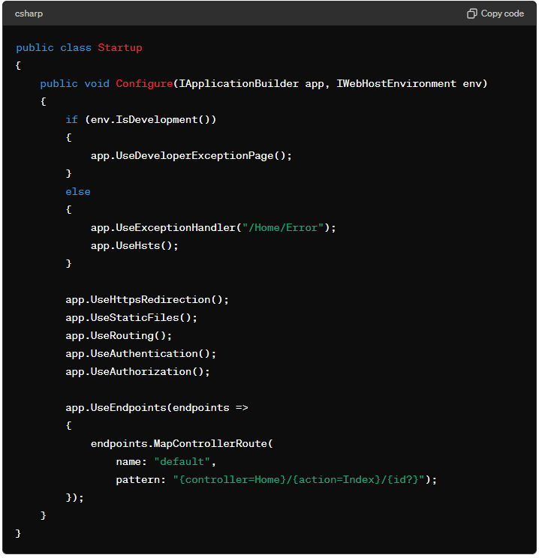

1. **Developer Exception Page**:
   * **app.UseDeveloperExceptionPage()**: Shows detailed error information when an exception occurs in the development environment.
2. **Exception Handler**:
   * **app.UseExceptionHandler("/Home/Error")**: Handles exceptions by redirecting to a specified route in a production environment.
3. **HTTP Strict Transport Security (HSTS)**:
   * **app.UseHsts()**: Adds HTTP Strict Transport Security headers to responses.
4. **HTTPS Redirection**:
   * **app.UseHttpsRedirection()**: Redirects HTTP requests to HTTPS.
5. **Static Files**:
   * **app.UseStaticFiles()**: Serves static files from the **wwwroot** folder.
6. **Routing**:
   * **app.UseRouting()**: Adds routing capabilities to the middleware pipeline.
7. **Authentication**:
   * **app.UseAuthentication()**: Enables authentication services.
8. **Authorization**:
   * **app.UseAuthorization()**: Enables authorization services.
9. **Endpoints**:
   * **app.UseEndpoints()**: Defines endpoints for the request pipeline.

**Custom Middleware**

You can also create custom middleware to handle specific tasks. Here's an example of custom middleware that logs request details:

**Summary**

Middleware components are crucial in ASP.NET Core for building the request processing pipeline. They enable a modular approach to handling requests and responses, allowing for a clean, maintainable, and extendable architecture. By using built-in middleware components and creating custom ones, developers can control the flow of HTTP requests through their application.

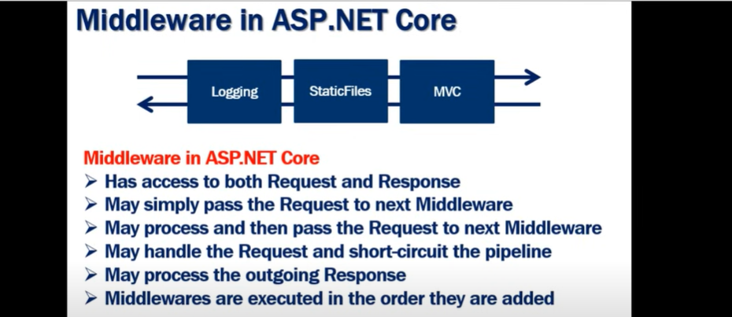

**How do you configure middleware in ASP.NET Core?**

In ASP.NET Core, middleware components are configured in the **Startup** class, specifically in the **Configure** method. Middleware are components that form the request pipeline, processing requests and responses.

Here’s how you configure middleware in ASP.NET Core:

**Step-by-Step Guide to Configure Middleware**

**Step 1: Create the Middleware**

You can create custom middleware by defining a class with an **Invoke** or **InvokeAsync** method.

**What is dependency injection, and how is it used in ASP.NET Core?**

**What is Dependency Injection?**

**Dependency Injection (DI)** is a design pattern used to achieve Inversion of Control (IoC) between classes and their dependencies. It allows a class to receive its dependencies from an external source rather than creating them internally. This makes the code more modular, testable, and maintainable.

**Benefits of Dependency Injection**

1. **Decoupling**: It reduces the tight coupling between classes.
2. **Ease of Testing**: Makes it easier to mock dependencies for unit testing.
3. **Manageability**: Centralizes the configuration of dependencies.
4. **Flexibility**: Allows for changing implementations without modifying the dependent classes.

**How is Dependency Injection Used in ASP.NET Core?**

ASP.NET Core has built-in support for Dependency Injection. It is a fundamental part of the framework and is used extensively in the startup and configuration of an application.

**Steps to Use Dependency Injection in ASP.NET Core**

1. **Register Services**: Configure the services your application needs in the **Startup** class.
2. **Inject Services**: Use constructor injection to get instances of these services in your classes.

**How do you configure routing in ASP.NET Core?**

Routing in ASP.NET Core is a powerful feature that enables you to map incoming requests to specific endpoints (e.g., controllers, actions, Razor Pages). Here's how you can configure routing in ASP.NET Core:

**Basic Routing Configuration**

1. **Using Startup.cs**:
   * Routing is typically configured in the **Startup.cs** file in the **Configure** method.

**Example of Basic Routing in Startup.cs:**

**Attribute Routing**

* You can define routes directly on your controller actions using attributes. This provides more flexibility and is often used for RESTful APIs.

**Conventional Routing**

* Conventional routing is typically used for MVC applications where the route patterns are defined globally.

**Areas**

* Areas are used to partition a large application into smaller functional groups, each with its own set of controllers, views, and models.

**Working With Areas In ASP.NET Core 3.1.pdf**

**Razor Pages Routing**

* Razor Pages have their own routing conventions and can be configured using **AddRazorPages**.

**How do you configure environment-specific settings in ASP.NET Core?**

In ASP.NET Core, you can configure environment-specific settings to ensure that your application behaves appropriately in different environments (such as development, staging, and production). This is typically done using environment-specific configuration files, environment variables, and the configuration API. Here's a detailed guide on how to set up and use environment-specific settings:

**Step-by-Step Guide**

**1. Environment-Specific Configuration Files**

You can create separate configuration files for each environment. The naming convention for these files is **appsettings.{Environment}.json**, where **{Environment}** is the name of the environment (e.g., **Development**, **Staging**, **Production**).

Example files:

* **appsettings.json**
* **appsettings.Development.json**
* **appsettings.Staging.json**
* **appsettings.Production.json**

When running your ASP.NET Core app on IIS, the value of **ASPNETCORE_ENVIRONMENT** can be set using the **web.config** file, system environment variables, or other configuration methods. The value will typically be **Production** in a live environment unless you explicitly set it to another value for staging or development purposes. To check or set this value, you can use the methods described above.

**What's the difference between appsettings.json and launchSettings.json**

**What's the difference between inprocess and outprcoess in dotnet core?**

In ASP.NET Core, the terms "in-process" and "out-of-process" refer to different modes of hosting the ASP.NET Core application in relation to the IIS (Internet Information Services) web server.

**In-Process Hosting**

* **Description**: In-process hosting means that the ASP.NET Core application runs within the IIS worker process (**w3wp.exe**).
* **Performance**: This mode offers better performance and lower latency because requests are handled directly by the IIS worker process without the need for proxying requests to an external process.
* **Configuration**: In-process hosting is configured in the **CreateDefaultBuilder** method in **Program.cs** file by specifying **UseIISIntegration()** and setting the **AspNetCoreHostingModel** to **InProcess** in the project file (**.csproj**).

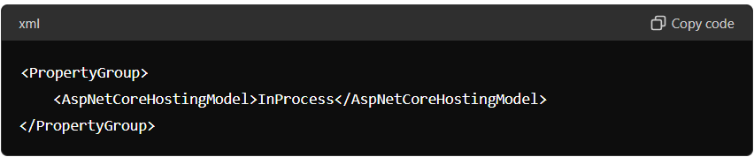

**Out-of-Process Hosting**

* **Description**: Out-of-process hosting means that the ASP.NET Core application runs as a separate process (e.g., **dotnet.exe**), and IIS acts as a reverse proxy server that forwards requests to the Kestrel server running the ASP.NET Core application.
* **Performance**: This mode can have slightly higher latency and overhead because requests are proxied from IIS to the Kestrel server.
* **Configuration**: Out-of-process hosting is configured by setting the **AspNetCoreHostingModel** to **OutOfProcess** in the project file (**.csproj**). The default for ASP.NET Core 2.2 and later is **InProcess**.

el>OutOfProcess</AspNetCoreHostingModel> </PropertyGroup>

**Key Differences**

1. **Performance**:
   * **In-Process**: Faster, as the application runs within the IIS worker process, eliminating the need for inter-process communication.
   * **Out-of-Process**: Slightly slower due to the additional overhead of proxying requests from IIS to Kestrel.
2. **Stability**:
   * **In-Process**: Potentially less stable because any issue in the ASP.NET Core application can affect the IIS worker process.
   * **Out-of-Process**: More isolation as the ASP.NET Core application runs in a separate process. Issues in the application do not directly affect the IIS worker process.
3. **Configuration**:
   * **In-Process**: Set **AspNetCoreHostingModel** to **InProcess**.
   * **Out-of-Process**: Set **AspNetCoreHostingModel** to **OutOfProcess**.
4. **Compatibility**:
   * **In-Process**: Available for ASP.NET Core applications running on Windows with IIS.
   * **Out-of-Process**: Available for cross-platform hosting scenarios where Kestrel can run independently or behind a different reverse proxy server like Nginx or Apache.
5. **Summary**
6. The choice between in-process and out-of-process hosting depends on the specific needs and constraints of your application. In-process hosting is generally preferred for better performance and simplicity in Windows environments, while out-of-process hosting offers better isolation and cross-platform compatibility.

**What is Kestrel, and what role does it play in ASP.NET Core?**

Kestrel is a cross-platform web server for ASP.NET Core. It is the default web server included with ASP.NET Core projects and plays a crucial role in hosting and serving web applications. Here’s an overview of what Kestrel is and its role in ASP.NET Core:

**What is Kestrel?**

* **Cross-Platform**: Kestrel is designed to run on multiple operating systems, including Windows, macOS, and Linux.
* **High-Performance**: Kestrel is built on top of the libuv or the newer .NET Sockets library, which makes it very fast and efficient.
* **Lightweight**: Kestrel is a lightweight web server that can be easily integrated into ASP.NET Core applications.

**Role of Kestrel in ASP.NET Core**

1. **Web Server**: Kestrel acts as a web server that listens for HTTP requests and forwards them to the ASP.NET Core application for processing. It handles the HTTP protocol and manages connections, making it the entry point for web traffic in an ASP.NET Core application.
2. **Hosting**: Kestrel can be used as an edge server, directly exposed to the internet, or as an internal server behind a reverse proxy (such as IIS, Nginx, or Apache). In a reverse proxy configuration, Kestrel handles the application logic while the reverse proxy handles tasks like SSL termination, load balancing, and serving static files.
3. **Flexibility**: Kestrel can be configured to run with different protocols, such as HTTP/1.1, HTTP/2, and even WebSockets, making it a versatile choice for various types of applications.

### **Summary**

Kestrel is an integral part of ASP.NET Core that provides a high-performance, cross-platform web server for hosting applications. It can be used on its own or behind a reverse proxy to handle incoming HTTP requests. Its configuration flexibility allows developers to tailor it to the needs of their application, ensuring optimal performance and security.

**What is the Model-View-Controller (MVC) pattern?**

The Model-View-Controller (MVC) pattern is a design pattern used in software development to separate the application into three interconnected components: Model, View, and Controller. This separation helps to manage complex applications by organizing code and responsibilities, improving modularity, and facilitating testing and maintenance.

**Components of MVC**

1. **Model**:
   * **Purpose**: Represents the data and the business logic of the application.
   * **Responsibilities**:
     + Manages the data of the application.
     + Enforces business rules and logic.
     + Directly manages the data and state, often interacting with the database.
   * **Examples**: Classes that represent entities in the application, such as **Customer**, **Order**, and **Product**.
2. **View**:
   * **Purpose**: Represents the presentation layer of the application.
   * **Responsibilities**:
     + Displays the data from the Model to the user.
     + Collects user input and sends it to the Controller.
   * **Examples**: HTML, CSS, Razor views, and other UI elements that render the user interface.
3. **Controller**:
   * **Purpose**: Acts as an intermediary between the Model and the View.
   * **Responsibilities**:
     + Handles user input and interactions.
     + Processes input from the View and updates the Model.
     + Decides which View to render based on user interactions and Model state.
   * **Examples**: Methods in the Controller classes that handle HTTP requests and responses.

**How MVC Works**

1. **User Interaction**: A user interacts with the View (e.g., by clicking a button or submitting a form).
2. **Request Handling**: The Controller handles the user input, processes the request, and makes decisions about what should happen next.
3. **Model Update**: The Controller updates the Model based on the user input. This might involve reading or writing data to a database.
4. **View Update**: The Model notifies the View of any changes (directly or through the Controller). The View then retrieves the updated data from the Model and updates the user interface accordingly.

**Example Workflow in an ASP.NET Core MVC Application**

1. **User Action**: A user navigates to a URL (e.g., **/Products/Details/1**).
2. **Routing**: The ASP.NET Core routing system directs the request to the appropriate Controller (e.g., **ProductsController**) and action method (e.g., **Details**).
3. **Controller Action**: The **Details** action method in the **ProductsController** retrieves product details from the Model (e.g., a **Product** class or database context).
4. **Model Data**: The **Product** data is retrieved and passed to the View.
5. **View Rendering**: The View (e.g., **Details.cshtml**) uses the Model data to generate HTML and present it to the user.

**What is the role of the [ApiController] attribute in ASP.NET Core?**

The **[ApiController]** attribute in ASP.NET Core plays a significant role in making the development of Web APIs easier and more robust. When applied to a controller, this attribute provides several benefits and conventions that help streamline API development. Here are the main roles and benefits of using the **[ApiController]** attribute:

**Role and Benefits of [ApiController] Attribute**

1. **Automatic Model State Validation:**
   * When you use the **[ApiController]** attribute, ASP.NET Core automatically checks the model state before executing the action method. If the model state is invalid, it returns a **400 Bad Request** response with details of the validation errors. This removes the need for manual model state checks in your action methods.) { // Action method logic here... }
2. **Attribute Routing Requirement:**
   * Controllers decorated with **[ApiController]** require attribute routing to be used. This helps ensure that the routing is explicitly defined and makes the route handling more predictable.Action methods here... }
3. **Binding Source Parameter Inference:**
   * The **[ApiController]** attribute automatically infers the binding source for action parameters. For example, it can distinguish between **[FromBody]**, **[FromQuery]**, and **[FromRoute]** based on the parameter type and name.logic here... }
4. **Problem Details for Error Responses:**
   * By default, the **[ApiController]** attribute formats error responses using the RFC 7807 specification for problem details. This provides a standardized format for representing errors in HTTP APIs.
5. **Enhanced API Behavior:**
   * The **[ApiController]** attribute enhances the behavior of controllers in several other ways, such as requiring non-nullable reference types to be checked for null values and generating more descriptive error messages for client errors.

**How do you handle JSON data in ASP.NET Core Web API?**

Handling JSON data in an ASP.NET Core Web API is straightforward thanks to the built-in support for JSON serialization and deserialization provided by the framework.

**JSON Serialization Settings (Optional):** ASP.NET Core uses **System.Text.Json** by default for JSON serialization and deserialization. If you need to customize JSON serialization settings, you can do so in the **Startup.cs** file.

**How do you return different types of responses from a Web API controller?**

**1. Return an Object or Collection**

If you want to return data, such as a single object or a collection of objects, you can simply return it. ASP.NET Core will serialize the object to JSON by default.

**2. Return a Status Code**

You can use the **StatusCode** method to return a specific HTTP status code.esponse }

**3. Return an HTTP Status Code with a Message**

You can return an HTTP status code along with a message or an object.

**4. Use ActionResult<T> for Flexibility**

**ActionResult<T>** allows you to return either an object or an HTTP status code.

**5. Return a Problem Details Response**

You can return a **ProblemDetails** response for standardized error information.

**Summary**

* **Return Data:** Return objects or collections directly.
* **Return Status Codes:** Use methods like **BadRequest**, **NotFound**, **CreatedAtAction**, and **NoContent**.
* **Flexible Returns:** Use **ActionResult<T>** for flexible responses.
* **Standardized Errors:** Use **ProblemDetails** for standardized error responses.

These practices allow you to provide a wide range of responses, improving the clarity and flexibility of your Web API.

**What are the different authentication methods available in ASP.NET Core?**

ASP.NET Core supports several authentication methods to help secure web applications. These methods provide various ways to authenticate users, including traditional username/password authentication, token-based authentication, and third-party authentication providers. Here are the different authentication methods available in ASP.NET Core:

**1. Cookie Authentication**

Cookie authentication is a common approach for web applications. It involves issuing a cookie to the client upon successful authentication, which is then sent with each subsequent request.

**2. JWT Bearer Authentication**

JWT (JSON Web Token) authentication is widely used in APIs for stateless authentication. A JWT is issued to the client after successful authentication and is included in the Authorization header of each request.

**3. OAuth 2.0 and OpenID Connect**

OAuth 2.0 and OpenID Connect are used for authentication and authorization with third-party providers like Google, Facebook, Microsoft, and others. ASP.NET Core supports these protocols through middleware.

**4. Windows Authentication**

Windows authentication is used for intranet applications to authenticate users based on their Windows credentials. This method uses the Kerberos or NTLM protocols.

**5. API Key Authentication**

API key authentication is a simple way to secure APIs by requiring clients to include an API key in their requests. This can be implemented using middleware.

**6. IdentityServer4**

IdentityServer4 is a framework for implementing authentication and authorization using OpenID Connect and OAuth 2.0. It's useful for building single sign-on (SSO) solutions and securing APIs.

**7. Social Authentication**

ASP.NET Core supports authentication via social providers like Google, Facebook, Twitter, and Microsoft. This is usually implemented via OAuth 2.0.

**Summary**

ASP.NET Core provides a versatile set of authentication methods to cater to different types of applications, whether they are traditional web applications, APIs, or hybrid solutions requiring third-party integrations. The choice of authentication method depends on the specific needs and security requirements of the application.

**What is IdentityServer4, and how is it used in ASP.NET Core?**

**IdentityServer4** is an open-source framework for building secure identity and access management solutions in ASP.NET Core applications. It allows you to implement authentication, authorization, and single sign-on (SSO) for your applications using industry-standard protocols such as OAuth 2.0 and OpenID Connect.

**What is the IServiceCollection interface?**

he **IServiceCollection** interface in ASP.NET Core is used for configuring and registering services that are used by your application's dependency injection (DI) container. It is part of the dependency injection framework provided by ASP.NET Core and is typically used in the **ConfigureServices** method of your application's **Startup** class.

Here's a brief overview of how **IServiceCollection** is used:

1. **Service Registration**: You use **IServiceCollection** to register services with the DI container. This is done using the **Add** family of methods, such as **AddTransient**, **AddScoped**, and **AddSingleton**. For example:

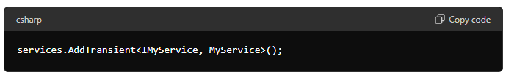

This registers **MyService** as an implementation of **IMyService** with a transient lifetime, meaning a new instance will be created each time it is requested.

1. **Configuration**: Some services might require configuration parameters. You can use **IServiceCollection** to configure these services. For example, to configure a database connection:

This configures **MyDbContext** to use SQL Server with a connection string retrieved from configuration.

1. **Customization**: **IServiceCollection** allows you to customize the behavior of the DI container. You can do this by chaining method calls to further configure services. For example:

This customizes the JSON serialization options used by the MVC framework.

In summary, **IServiceCollection** is a central interface in ASP.NET Core for configuring services and dependencies used throughout your application. It provides a fluent API for registering and configuring services with the DI container.

**What are the different service lifetimes in ASP.NET Core?**

**Transient – Scoped – Singleton**

Correct! In ASP.NET Core, services can be registered with three different lifetimes:

1. **Transient:** Transient services are created each time they are requested. This means that a new instance of the service is created for every injection. Transient services are suitable for lightweight, stateless services.
2. **Scoped:** Scoped services are created once per request within the scope. In a web application, this means that the service is created once for each HTTP request and is available for the entire request. Scoped services are useful for sharing state within the scope of a request.
3. **Singleton:** Singleton services are created the first time they are requested and are reused for all subsequent requests. Singleton services are shared across all requests and are suitable for services that are expensive to create or that need to maintain state throughout the application's lifetime.

These lifetimes allow you to control how instances of services are managed and shared within your application, helping you optimize performance and resource usage.

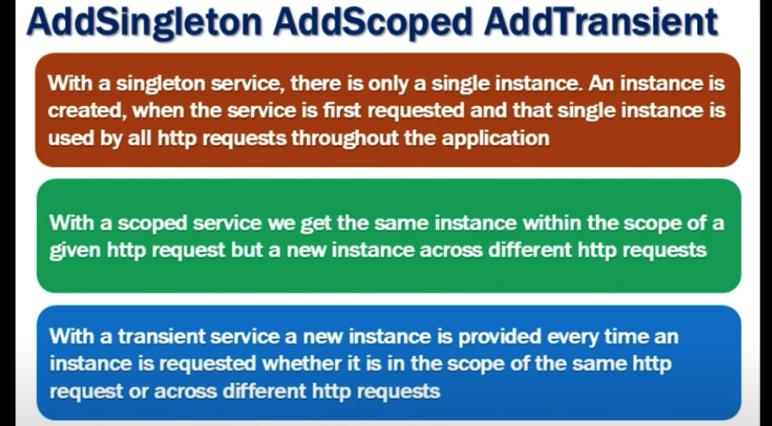

**Give me real examples for each one-off them?**

1. **Transient:** Consider a logging service (**ILogger**) that logs messages to a data store. Since logging messages typically do not require state to be maintained between requests and each log entry is independent, the logging service can be registered as transient. This ensures that a new instance of the logging service is created each time it is injected, allowing for efficient logging without sharing state between requests.

DatabaseLogger>();

1. **Scoped:** Suppose you have a service that manages user authentication and authorization (**IAuthService**). This service may need to maintain user-related data or perform database queries based on the current user's identity. In a web application, you can register this service as scoped to ensure that the same instance is reused throughout the duration of an HTTP request, allowing it to maintain state specific to the current user's session.

1. **Singleton:** Consider a configuration service (**IConfigService**) that loads application settings from a configuration file and provides them to other parts of the application. Since these settings are typically static and do not change frequently, you can register the configuration service as a singleton. This ensures that the same instance of the configuration service is shared across all requests and throughout the lifetime of the application, avoiding unnecessary overhead of loading configuration data multiple times.

These examples demonstrate how you can choose the appropriate service lifetime based on the behavior and requirements of your application components.

**How do you set up Entity Framework Core in an ASP.NET Core project?**

To set up Entity Framework Core in an ASP.NET Core project, follow these steps:

1. **Install Entity Framework Core Packages**
2. **Create the Data Model**
3. **Create the Database Context**
4. **Configure the Database Context in Startup**
5. **Add the Connection String**
6. **Create and Apply Migrations**

**1. Install Entity Framework Core Packages**

Use NuGet to install the necessary Entity Framework Core packages. Open the Package Manager Console or use the NuGet Package Manager in Visual Studio.

**Using Package Manager Console:**

**Using .NET CLI:**

**4. Configure the Database Context in Startup**

Register the **DbContext** with the dependency injection container in the **ConfigureServices** method of the **Startup** class.

**5. Add the Connection String**

Add the connection string to the **appsettings.json** file.

**6. Create and Apply Migrations**

Use the Entity Framework Core tools to create and apply migrations, which will create the database schema based on your data model.

**Using Package Manager Console:**

**Using .NET CLI:**

**What is a DbContext, and how is it used in ASP.NET Core?**

A **DbContext** in Entity Framework (EF) Core is the primary class responsible for interacting with the database. It is the bridge between your application and the database, providing an API to perform CRUD (Create, Read, Update, Delete) operations, query the database, and manage changes to the data.

**Key Roles of DbContext:**

1. **Database Connection Management:** Manages the connection to the database.
2. **Configuration of the Model:** Configures the shape of the data model and relationships between data.
3. **Query Execution:** Allows querying the database using LINQ (Language Integrated Query).
4. **Change Tracking:** Keeps track of changes made to entities so that they can be persisted to the database.
5. **Data Manipulation:** Provides methods to add, update, and delete data.

### Summary

In summary, the **DbContext** class in Entity Framework Core serves as a central point for managing database connections and operations. It allows you to define your data models and interact with the database in a seamless and efficient manner. By configuring **DbContext** in your ASP.NET Core application, you enable smooth integration with the database, allowing for powerful data manipulation and querying capabilities.

**How do you seed data in Entity Framework Core?**

Seeding data in Entity Framework Core involves populating the database with initial data when the database is created or migrated. You can achieve this by overriding the **OnModelCreating** method in your **DbContext** class and using the **HasData** method to specify the seed data.

**Notes**

1. **Primary Keys**: Ensure that the entities you are seeding have their primary keys specified. If you don't set the primary keys, EF Core will consider them as new entries during every migration.
2. **Complex Relationships**: For entities with complex relationships, make sure to seed related entities first and use their primary keys in the dependent entities.
3. **Multiple Seeding**: You can seed multiple entities and set up their relationships by calling **HasData** on multiple entity types within **OnModelCreating**.

**How do you handle file uploads in ASP.NET Core?**

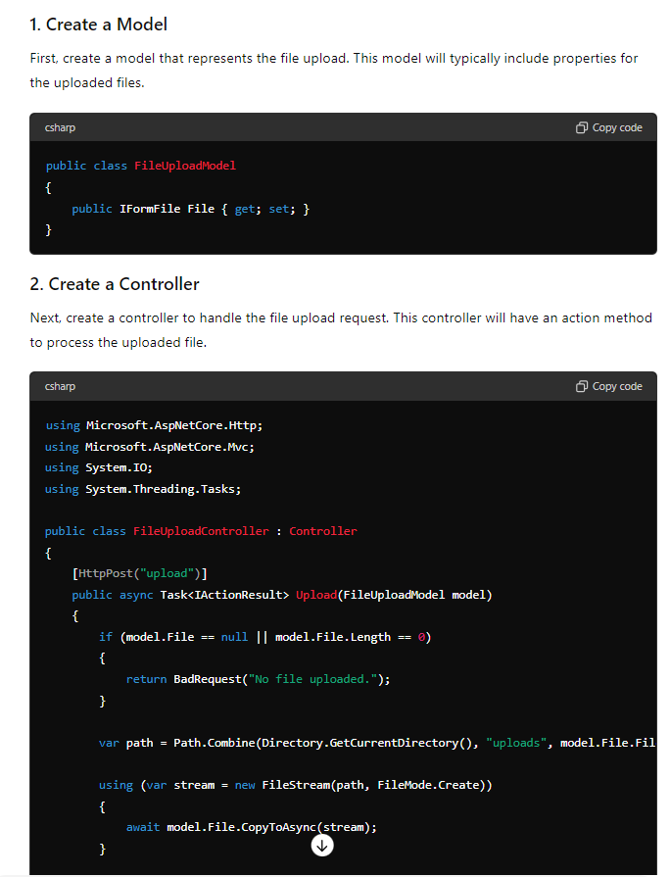

**How do you use SignalR for real-time communication in ASP.NET Core?**

SignalR is a library for ASP.NET Core that simplifies the process of adding real-time web functionality to applications. Real-time web functionality allows server-side code to push content to connected clients instantly.

**What are gRPC services, and how do you use them in ASP.NET Core?**

gRPC (gRPC Remote Procedure Calls) is a high-performance, open-source framework for building remote procedure call (RPC) services. It uses HTTP/2 for transport, Protocol Buffers (Protobuf) as the interface description language, and provides features such as authentication, load balancing, and more. gRPC is language-agnostic, meaning you can write services in one language and call them from clients written in another language.

gRPC is powerful for building high-performance, cross-platform services with strongly-typed contracts and efficient binary serialization. It’s well-suited for microservices, real-time communication, and applications requiring high throughput and low latency.

**How do you implement background tasks in ASP.NET Core?**

In ASP.NET Core, background tasks can be implemented using several approaches, depending on the complexity and requirements of the tasks. Here are some common methods:

1. **Using Hosted Services**:
   * **IHostedService**: For simple background tasks, you can implement **IHostedService**.
   * **BackgroundService**: For more complex scenarios, you can inherit from **BackgroundService**, which provides a base class for long-running services.
2. **Using Hangfire**:
   * Hangfire is a popular library that enables the scheduling and execution of background jobs.
3. **Using Azure Functions**:
   * For cloud-native applications, Azure Functions can be used to run background tasks.

**What is health monitoring, and how do you implement it in ASP.NET Core?**

Health monitoring in ASP.NET Core involves checking the status and health of an application, its services, and dependencies to ensure they are running as expected. This helps in identifying and resolving issues proactively, improving application reliability and availability. ASP.NET Core provides built-in support for health checks through the **Microsoft.Extensions.Diagnostics.HealthChecks** package.

Implementing health monitoring helps ensure your application remains reliable and can quickly alert you to any issues that arise, allowing for proactive management and resolution.

**How do you implement global exception handling in ASP.NET Core?**

Implementing global exception handling in ASP.NET Core can be achieved using middleware. This middleware can catch all unhandled exceptions that occur during the request processing pipeline and handle them in a centralized manner. Here’s how you can implement global exception handling in an ASP.NET Core application:

#### 1. Create a Middleware for Exception Handling

First, create a custom middleware that will handle exceptions.

#### Use Built-in Exception Handling Middleware

ASP.NET Core also provides a built-in exception handling middleware called **UseExceptionHandler**. You can use this middleware to handle exceptions in a centralized way and display user-friendly error pages.

**How do you implement HTTPS redirection in ASP.NET Core?**

Implementing HTTPS redirection in ASP.NET Core ensures that all HTTP requests are automatically redirected to HTTPS, enhancing the security of your application by encrypting the data transmitted between the client and server. Here’s how you can set up HTTPS redirection in an ASP.NET Core application:

* **Use Middleware**: Add **app.UseHttpsRedirection()** in the **Configure** method.
* **Configure Options**: Optionally configure HTTPS redirection options using **services.AddHttpsRedirection**.
* **Set HTTPS Port**: Ensure the HTTPS port is set correctly in **appsettings.json**.
* **Configure Kestrel**: Ensure Kestrel is configured to listen on both HTTP and HTTPS ports.

By following these steps, you can ensure that your ASP.NET Core application automatically redirects all HTTP requests to HTTPS, enhancing the security of your application.

**How do you configure CORS (Cross-Origin Resource Sharing) in ASP.NET Core?**

Configuring CORS (Cross-Origin Resource Sharing) in ASP.NET Core allows your web application to specify which external domains are permitted to access resources on your server. Here's how you can configure CORS in your ASP.NET Core application:

**Step-by-Step Configuration**

**1. Add the CORS Services**

In the **ConfigureServices** method of your **Startup.cs** file, add the CORS services to the service container.

**2. Use the CORS Middleware**

In the **Configure** method, add the CORS middleware before any other middleware that uses CORS (such as MVC).

**3. Apply CORS Policies at the Controller or Action Level (Optional)**

You can also apply CORS policies at the controller or action level using the **[EnableCors]** attribute. This is useful if you need different policies for different parts of your application.

**Same-origin policy**

The same-origin policy is a browser security feature that restricts how documents and scripts on one origin can interact with resources on another origin.

A browser can load and display resources from multiple sites at once. You might have multiple tabs open at the same time, or a site could embed multiple iframes from different sites. If there is no restriction on interactions between these resources, and a script is compromised by an attacker, the script could expose everything in a user's browser.

The same-origin policy prevents this from happening by blocking read access to resources loaded from a different origin. "But wait," you say, "I load images and scripts from other origins all the time." Browsers allow a few tags to embed resources from a different origin. This policy is mostly a historical artifact and can expose your site to vulnerabilities such as [clickjacking using iframes](https://web.dev/articles/same-origin-policy#how_to_prevent_clickjacking). You can restrict cross-origin reading of these tags using a [Content Security Policy](https://web.dev/articles/csp).

**How do you protect against XSS (Cross-Site Scripting) in ASP.NET Core?**

**Cross-Site Scripting (XSS)** is a type of security vulnerability typically found in web applications. XSS occurs when an attacker injects malicious scripts into content that is delivered to other users. This vulnerability allows attackers to execute scripts in the victim's browser, potentially leading to unauthorized access, data theft, or manipulation of web content.

**Types of XSS:**

1. **Stored XSS (Persistent):**
   * The malicious script is permanently stored on the target server (e.g., in a database) and is served to users whenever they request the affected content.
   * Example: An attacker injects a script into a comment field on a blog. Every time someone views that blog post, the script executes in their browser.
2. **Reflected XSS (Non-Persistent):**
   * The malicious script is reflected off the web server, typically via a URL or a form submission, and is immediately executed in the victim's browser.
   * Example: An attacker crafts a URL with malicious script embedded in a query string, and convinces a victim to click on it. The script is then reflected back and executed by the browser.
3. **DOM-based XSS:**
   * The vulnerability is in the client-side script that handles data, allowing an attacker to manipulate the DOM environment in the victim's browser.
   * Example: A client-side script reads data from the URL and writes it to the webpage without proper validation, leading to script execution.

**How to Protect Against XSS:**

1. **Input Validation and Sanitization:**
   * Always validate and sanitize user inputs on the server side. Ensure that any data that could be interpreted as code (such as HTML, JavaScript) is properly encoded.
   * Use functions provided by your framework to encode special characters (e.g., <, >, &, ", ') before inserting them into HTML. For example:
     + In ASP.NET, use Server.HtmlEncode() to encode output.
     + In JavaScript, use document.createTextNode() to safely insert user data into the DOM.
2. **Output Encoding:**
   * Properly encode data before displaying it in the browser. This ensures that even if malicious data gets through, it is rendered as text rather than executable code.
   * Different contexts require different encoding:
     + HTML Encoding: Encode data before inserting it into HTML elements.
     + Attribute Encoding: Encode data before inserting it into HTML attributes.
     + JavaScript Encoding: Encode data before inserting it into JavaScript code.
     + URL Encoding: Encode data before inserting it into URLs.
3. **Content Security Policy (CSP):**
   * Implement CSP headers to restrict the sources from which scripts can be loaded. This can prevent the execution of unauthorized scripts, even if they are injected into your application.
   * Example CSP header:

http

Copy code

Content-Security-Policy: default-src 'self'; script-src 'self' https://trusted.cdn.com;

1. **HTTPOnly and Secure Cookies:**
   * Use HttpOnly and Secure flags for cookies to protect them from being accessed via JavaScript and to ensure they are only sent over HTTPS connections.
   * Example in ASP.NET:

csharp

Copy code

var cookie = new HttpCookie("AuthToken")

{

HttpOnly = true,

Secure = true

};

1. **Avoid Inline JavaScript:**
   * Avoid including inline JavaScript and event handlers directly in HTML. Instead, use external scripts or event listeners in your JavaScript files.
   * This makes it easier to implement a strict CSP and reduces the risk of XSS.
2. **Regular Security Audits and Testing:**
   * Regularly audit your application for XSS vulnerabilities using automated tools and manual testing.
   * Implement security practices in your development process, such as code reviews and the use of security-focused static analysis tools.
3. **Use Security Libraries and Frameworks:**
   * Utilize libraries and frameworks that offer built-in protections against XSS. For example:
     + ASP.NET WebForms and MVC provide automatic encoding in certain contexts (e.g., Html.Encode, Razor syntax).
     + Angular and React have built-in mechanisms to prevent XSS by escaping dangerous content automatically.

**Summary:**

XSS is a serious security vulnerability that allows attackers to inject and execute malicious scripts in a user's browser. Protecting against XSS involves a combination of input validation, output encoding, CSP implementation, secure cookie practices, avoiding inline scripts, and regular security testing. By following these best practices, you can significantly reduce the risk of XSS attacks in your web applications.

**How do you protect against CSRF (Cross-Site Request Forgery) in ASP.NET Core?**

Cross-Site Request Forgery (CSRF) is an attack that forces an authenticated user to execute unwanted actions on a web application in which they are currently authenticated. In ASP.NET Core, CSRF protection is built-in and can be enabled through the use of anti-forgery tokens.

Here are the steps to protect against CSRF in ASP.NET Core:

**1. Enable Anti-Forgery Tokens**

ASP.NET Core includes built-in middleware to protect against CSRF attacks by generating and validating anti-forgery tokens.

**2. Add Anti-Forgery Tokens to Forms**

To protect your forms against CSRF, you need to include anti-forgery tokens in your HTML forms. ASP.NET Core provides the **@Html.AntiForgeryToken()** helper to generate these tokens.

**3. Validate Anti-Forgery Tokens in Controllers**

In your controllers, you can use the **[ValidateAntiForgeryToken]** attribute to ensure that the token is validated on form submission.

**Summary**

By following these steps, you can effectively protect your ASP.NET Core applications against CSRF attacks. The built-in anti-forgery middleware generates and validates tokens, ensuring that any form submission or AJAX request originates from your application and not from a malicious site.

**How do you unit test ASP.NET Core applications?**

Unit testing ASP.NET Core applications involves writing tests for individual components, such as controllers, services, and repositories, to ensure they behave as expected. Here's a step-by-step guide to unit testing in ASP.NET Core:

**1. Set Up Your Test Project**

First, create a separate test project in your solution. This project will contain your unit tests.

**Using Visual Studio:**

* Right-click on your solution.
* Select **Add** > **New Project**.
* Choose **xUnit Test Project** (or **NUnit Test Project**, depending on your preference).
* Name the project (e.g., **MyApp.Tests**).

**How do you use TestServer for testing ASP.NET Core applications?**

**TestServer** is a part of the **Microsoft.AspNetCore.TestHost** package and is used for creating in-memory HTTP servers for testing ASP.NET Core applications. It allows you to test your application's middleware, routing, and other components without requiring an actual web server.

**Summary**

Using **TestServer** allows you to create an in-memory HTTP server to test your ASP.NET Core application's middleware, routing, and endpoints without needing a real server. This can help you perform integration tests efficiently and ensure your application behaves as expected. By following the steps outlined above, you can set up and run tests for your ASP.NET Core application using **TestServer**.

**How do you deploy an ASP.NET Core application to IIS?**

Deploying an ASP.NET Core application to IIS involves several steps, including preparing your application, installing the necessary prerequisites on the server, configuring IIS, and deploying your application files. Here’s a step-by-step guide to help you through the process:

**1. Prepare Your Application**

1. **Publish Your Application:** Use the .NET CLI or Visual Studio to publish your application. This will create a folder with all the files needed to run your application.

**Using Visual Studio:**

* + Right-click on the project in Solution Explorer.
  + Select **Publish**.
  + Choose **Folder** as the target and configure the path.

**2. Install .NET Core Hosting Bundle on IIS Server**

The .NET Core Hosting Bundle installs the .NET Core Runtime, .NET Core Library, and the ASP.NET Core Module. This module allows ASP.NET Core apps to run behind IIS.

1. **Download the Hosting Bundle:** [Download .NET Core Hosting Bundle](https://dotnet.microsoft.com/download/dotnet-core/thank-you/runtime-aspnetcore-3.1.18-windows-hosting-bundle-installer)
2. **Install the Hosting Bundle:** Run the installer on the server.

**3. Configure IIS**

1. **Open IIS Manager:**
   * Open **Server Manager** and select **IIS** from the left-hand menu.
   * Click on **Internet Information Services (IIS) Manager**.
2. **Add a New Website:**
   * Right-click on **Sites** in the Connections pane.
   * Select **Add Website**.
   * Configure the **Site name**, **Physical path** (the path to your published application), and **Binding** information (e.g., port 80 for HTTP).
3. **Configure the Application Pool:**
   * Ensure the application pool is set to use **No Managed Code** since the ASP.NET Core Module handles the process.
   * Right-click the new site and select **Manage Website** > **Advanced Settings**.
   * Set the **.NET CLR version** to **No Managed Code**.
4. **Set Permissions:**
   * Make sure the **IIS_IUSRS** group has read and execute permissions on your application's folder.

**4. Deploy Your Application**

1. **Copy Files to the Server:**
   * Copy the contents of the published folder to the physical path you specified when creating the IIS site.
2. **Configure web.config:**
   * Ensure your **web.config** file in the published folder is correctly set up to use the ASP.NET Core Module. The **web.config** should look something like this:

**5. Configure Firewall**

1. **Open Port:**
   * Ensure that the port your site is bound to (e.g., port 80 for HTTP) is open on the server’s firewall.

**6. Browse Your Application**

1. **Access Your Site:**
   * Open a web browser and navigate to the URL of your deployed application (e.g., **http://yourserver** or **http://yourserver:port**).

**Summary**

By following these steps, you can deploy your ASP.NET Core application to IIS. Ensure that your application is correctly published, the server has the necessary .NET Core Hosting Bundle installed, IIS is configured properly, and your application files are in the right location with the correct permissions. This setup will allow your ASP.NET Core application to run smoothly behind IIS.

**What is the role of the web.config file in ASP.NET Core applications?**

**How do you use caching in ASP.NET Core?**

Caching in ASP.NET Core can significantly improve the performance and scalability of your applications by reducing the need to process the same data multiple times. There are several types of caching available in ASP.NET Core, including in-memory caching, distributed caching, and response caching. Below, we'll go through how to set up and use each type of caching.

**1. In-Memory Caching**

In-memory caching stores data in the memory of the web server and is ideal for small to medium-sized applications or when caching per-server is acceptable.

**Step-by-Step Example:**

1. **Install the Package** (if not already included):

sh

Copy code

dotnet add package Microsoft.Extensions.Caching.Memory

1. **Configure Services** in Startup.cs:

csharp

Copy code

public void ConfigureServices(IServiceCollection services)

{

services.AddMemoryCache();

services.AddControllersWithViews();

}

1. **Use In-Memory Cache** in a Controller:

csharp

Copy code

public class HomeController : Controller

{

private readonly IMemoryCache _cache;

public HomeController(IMemoryCache cache)

{

_cache = cache;

}

public IActionResult Index()

{

string cacheKey = "currentTime";

if (!_cache.TryGetValue(cacheKey, out string cachedTime))

{

cachedTime = DateTime.Now.ToString();

_cache.Set(cacheKey, cachedTime, TimeSpan.FromMinutes(5));

}

ViewData["CachedTime"] = cachedTime;

return View();

}

}

**2. Distributed Caching**

Distributed caching stores data in an external system (e.g., Redis, SQL Server) that can be shared across multiple servers.

**Using Redis Distributed Cache:**

1. **Install the Package**:

sh

Copy code

dotnet add package Microsoft.Extensions.Caching.StackExchangeRedis

1. **Configure Services** in Startup.cs:

csharp

Copy code

public void ConfigureServices(IServiceCollection services)

{

services.AddStackExchangeRedisCache(options =>

{

options.Configuration = "localhost"; // Your Redis server address

options.InstanceName = "SampleInstance";

});

services.AddControllersWithViews();

}

1. **Use Redis Cache** in a Controller:

csharp

Copy code

public class HomeController : Controller

{

private readonly IDistributedCache _cache;

public HomeController(IDistributedCache cache)

{

_cache = cache;

}

public async Task<IActionResult> Index()

{

string cacheKey = "currentTime";

var cachedTime = await _cache.GetStringAsync(cacheKey);

if (string.IsNullOrEmpty(cachedTime))

{

cachedTime = DateTime.Now.ToString();

await _cache.SetStringAsync(cacheKey, cachedTime, new DistributedCacheEntryOptions

{

AbsoluteExpirationRelativeToNow = TimeSpan.FromMinutes(5)

});

}

ViewData["CachedTime"] = cachedTime;

return View();

}

}

**3. Response Caching**

Response caching reduces the number of requests a client makes to a server and the number of times a server processes the same requests.

**Configure Response Caching:**

1. **Configure Services** in Startup.cs:

csharp

Copy code

public void ConfigureServices(IServiceCollection services)

{

services.AddResponseCaching();

services.AddControllersWithViews();

}

1. **Configure Middleware** in Startup.cs:

csharp

Copy code

public void Configure(IApplicationBuilder app, IWebHostEnvironment env)

{

if (env.IsDevelopment())

{

app.UseDeveloperExceptionPage();

}

else

{

app.UseExceptionHandler("/Home/Error");

app.UseHsts();

}

app.UseHttpsRedirection();

app.UseStaticFiles();

app.UseRouting();

app.UseAuthorization();

app.UseResponseCaching();

app.UseEndpoints(endpoints =>

{

endpoints.MapControllerRoute(

name: "default",

pattern: "{controller=Home}/{action=Index}/{id?}");

});

}

1. **Apply Response Caching** in a Controller:

csharp

Copy code

[ResponseCache(Duration = 60, Location = ResponseCacheLocation.Client)]

public class HomeController : Controller

{

public IActionResult Index()

{

ViewData["CachedTime"] = DateTime.Now.ToString();

return View();

}

}

**Summary**

* **In-Memory Caching**: Simple and effective for single-server scenarios.
* **Distributed Caching**: Suitable for scalable and distributed systems, with options like Redis and SQL Server.
* **Response Caching**: Caches the output of HTTP responses to reduce server load and improve client performance.

Using these caching techniques appropriately can help reduce load times, increase throughput, and provide a better user experience.

**What is response compression, and how do you implement it in ASP.NET Core?**

Response compression is a technique used to reduce the size of the HTTP responses sent from the server to the client. By compressing the response data, the amount of bandwidth used is reduced, leading to faster load times and improved performance, especially over slow network connections. Common compression algorithms include Gzip and Brotli.

**What are tag helpers in ASP.NET Core?**

**Tag Helpers in ASP.NET Core**

Tag Helpers in ASP.NET Core are a way to make server-side code participate in creating and rendering HTML elements in Razor files. They provide an HTML-friendly development experience by enabling Razor markup to be more readable and maintainable. Tag Helpers can manipulate HTML attributes and content based on server-side logic, bridging the gap between server-side and client-side code.

Key Features of Tag Helpers

1. HTML-like Syntax: Tag Helpers use an HTML-like syntax which makes it easy for developers to understand and work with them.
2. IntelliSense Support: In Visual Studio, Tag Helpers benefit from full IntelliSense support, making development faster and reducing errors.
3. Built-in Tag Helpers: ASP.NET Core includes several built-in Tag Helpers for common tasks such as forms, links, and validation.
4. Custom Tag Helpers: You can create custom Tag Helpers to extend the functionality to suit your application's needs.

**Summary**

Tag Helpers in ASP.NET Core provide a powerful way to enhance your HTML with server-side logic while maintaining a clean and readable HTML syntax. They come with several built-in helpers for common scenarios and allow for the creation of custom helpers to meet specific requirements. This makes them a valuable tool for developers working with Razor views in ASP.NET Core.

**What is ViewComponent in ASP.NET Core?**

In ASP.NET Core, a **ViewComponent** is a powerful feature used to encapsulate reusable rendering logic. It’s similar to partial views but more powerful, allowing you to include complex logic and separate concerns effectively. ViewComponents are ideal for rendering dynamic parts of your web page that might require their own set of data and business logic, separate from the main view.

**Key Features of ViewComponents:**

* **Encapsulation**: ViewComponents encapsulate the rendering logic and data fetching into a single unit.
* **Reusable**: They can be reused across different views, providing a consistent way to render specific parts of a web page.
* **Strongly Typed**: ViewComponents are strongly typed, making them easier to work with compared to partial views.
* **Separation of Concerns**: They help in separating the concerns, allowing better organization of code and rendering logic.

**Creating a ViewComponent**

**Step 1: Create the ViewComponent Class**

1. **Create a new class**: The class should inherit from **ViewComponent**.
2. **Define the method**: Define a method named **Invoke** or **InvokeAsync** which returns a result of type **IViewComponentResult**.

### Partial Views

1. **Simplicity**:
   * Partial views are simple and primarily used to break down large views into smaller, reusable pieces.
   * They don’t have any associated logic and rely on the controller to pass the model to them.
2. **Usage**:
   * Partial views are used when you need to reuse a portion of a view, such as a header, footer, or a common form.
   * They are called from within views using the **@Html.Partial** or **@Html.RenderPartial** helper methods.
3. **Model Binding**:
   * Partial views rely on the model passed from the parent view or controller. They don't fetch data themselves.
4. **Rendering**:
   * Partial views are purely for rendering HTML. They don't encapsulate any business logic.

**What is the difference between Razor Pages and MVC in ASP.NET Core?**

Razor Pages and MVC (Model-View-Controller) are two approaches to building web applications in ASP.NET Core. While they share some similarities, they have distinct differences that cater to different development scenarios and preferences.

**Razor Pages**

1. **Page-based Approach**:
   * Razor Pages are designed around a page-centric model where each page in the application corresponds to a physical **.cshtml** file.
   * Each page has a code-behind file that contains the page's logic, similar to how Web Forms work.
2. **Simplicity**:
   * Razor Pages aim to simplify the development of page-focused scenarios by removing the need for a separate controller. The page model acts as both the view and controller.
   * It reduces the complexity of dealing with controllers and views for simple page-centric applications.
3. **File Structure**:
   * Razor Pages are organized in a folder structure that maps directly to the URL structure of the application. For example, a page located at **/Pages/Index.cshtml** would be accessed via **/Index**.
4. **PageModel**:
   * Each Razor Page has an associated **PageModel** class that contains the logic and handlers for the page (e.g., **OnGet**, **OnPost**).
   * The **PageModel** class provides a cleaner separation of the page's logic and its HTML.
5. **Routing**:
   * Routing in Razor Pages is more straightforward since the URL pattern is based on the file path of the **.cshtml** files.
   * There is less configuration needed compared to setting up routes in MVC.

**MVC (Model-View-Controller)**

1. **Controller-based Approach**:
   * MVC is based on the separation of concerns principle where the application is divided into Models, Views, and Controllers.
   * Controllers handle user requests, interact with models, and select views to render the final output.
2. **Flexibility**:
   * MVC provides a more flexible and granular approach, allowing developers to have more control over routing, actions, and URL structures.
   * It is well-suited for complex applications that require fine-grained control over the application logic and routing.
3. **File Structure**:
   * MVC projects typically have separate folders for Models, Views, and Controllers.
   * This separation helps in organizing the codebase, especially for large applications.
4. **Action Methods**:
   * Controllers in MVC contain action methods that correspond to user interactions. Each action method can return different views or data based on the request.
5. **Routing**:
   * Routing in MVC is more configurable and can handle complex URL patterns and parameterized routes.
   * Routes are usually defined in the **Startup** class or using attribute routing on controllers and actions.

**Key Differences**

1. **Architecture**:
   * **Razor Pages**: Page-centric architecture where each page has its own logic and view combined.
   * **MVC**: Controller-centric architecture where controllers manage the interaction between models and views.
2. **Complexity**:
   * **Razor Pages**: Simpler for page-focused scenarios, reducing the need for controllers.
   * **MVC**: More suitable for complex applications requiring detailed control over routing and interactions.
3. **Separation of Concerns**:
   * **Razor Pages**: Combines view and logic in a single file (**.cshtml** with code-behind).
   * **MVC**: Separates concerns into distinct models, views, and controllers.
4. **Routing**:
   * **Razor Pages**: Routing is based on file paths, making it more straightforward.
   * **MVC**: Routing is more flexible and configurable, suitable for complex URL patterns.
5. **Usage Scenarios**:
   * **Razor Pages**: Ideal for simple, page-centric applications where each page is self-contained.
   * **MVC**: Ideal for larger applications with complex interactions and multiple view types.

**When to Use Each**

* **Use Razor Pages**:
  + For simple, page-centric applications where you want to reduce complexity.
  + When you prefer a more streamlined approach without the need for separate controllers.
  + For scenarios where the URL structure closely matches the file structure.
* **Use MVC**:
  + For complex applications requiring fine-grained control over routing, interactions, and multiple views.
  + When you need to separate concerns more clearly, especially for large teams and projects.
  + For applications where you need to handle multiple types of requests and responses (e.g., JSON, HTML).

**What is Blazor, and how does it relate to ASP.NET Core?**

Blazor is a framework for building interactive web applications using C# and .NET, and it is a part of ASP.NET Core. Here’s a detailed explanation of Blazor and its relation to ASP.NET Core:

**What is Blazor?**

Blazor is a single-page application (SPA) framework developed by Microsoft. It allows developers to build web applications using C# instead of JavaScript. Blazor uses WebAssembly (Wasm) to run .NET code directly in the browser, enabling full-stack web development with .NET.

**Key Features of Blazor:**

1. **Full-Stack Development with .NET:** Developers can use C# for both client-side and server-side development.
2. **Component-Based Architecture:** Blazor apps are built using reusable components, similar to other modern front-end frameworks like React or Angular.
3. **WebAssembly (Blazor WebAssembly):** Runs .NET code directly in the browser using WebAssembly, providing near-native performance.
4. **Server-Side Blazor (Blazor Server):** Executes the application logic on the server and uses SignalR to handle UI updates, making it possible to run Blazor apps on older browsers.
5. **Interoperability:** Blazor allows the use of JavaScript libraries and APIs alongside .NET code.
6. **Rich Ecosystem:** Integrates seamlessly with the ASP.NET Core ecosystem, leveraging existing libraries, tools, and services.

**Types of Blazor:**

1. **Blazor WebAssembly (Blazor WASM):** Runs client-side in the browser on WebAssembly.
2. **Blazor Server:** Runs server-side on the server, with real-time UI updates sent to the browser via SignalR.

**How Blazor Relates to ASP.NET Core:**

1. **Part of ASP.NET Core:** Blazor is included as a feature of ASP.NET Core, allowing developers to create SPAs within the ASP.NET Core framework.
2. **Shared Libraries:** Blazor applications can use ASP.NET Core libraries and middleware, providing a consistent development experience across the stack.
3. **Hosting Models:** Blazor WebAssembly apps can be hosted on static file servers, while Blazor Server apps require an ASP.NET Core server for rendering.
4. **Integrated Services:** Blazor can use ASP.NET Core services such as dependency injection, configuration, and logging, facilitating full-stack development.